**Project Initialization and Planning Phase**

| Date | 15 September2024 |
| --- | --- |
| Team ID | 739734 |
| Project Name | Ai-powered vehicle damage assessment and cost estimation for insurance claims |
| Maximum Marks | 3 Marks |

**Define Problem Statements**

**Problem Statement:**

**The Issue: The problem lies in the inefficiency and inaccuracies of traditional vehicle damage assessment and cost estimation processes for insurance claims, which often rely on manual inspection and subjective judgment. This leads to prolonged claim processing times, human errors, and inconsistent assessments, ultimately resulting in customer dissatisfaction and increased operational costs for insurance companies. There is a growing need for an AI-powered solution that can automate damage detection, accurately assess repair costs, and streamline the claims process, reducing both time and financial burdens for all parties involved.**

**Objective:** The objective of AI-powered vehicle damage assessment and cost estimation for insurance claims is to streamline and automate the claims process, ensuring faster, more accurate, and efficient evaluations. This involves using artificial intelligence (AI) technologies such as image recognition, machine learning, and telematics data analysis to assess the extent of vehicle damage, estimate repair costs, and generate claim payouts with minimal human intervention.

**.**

.

**Example:**

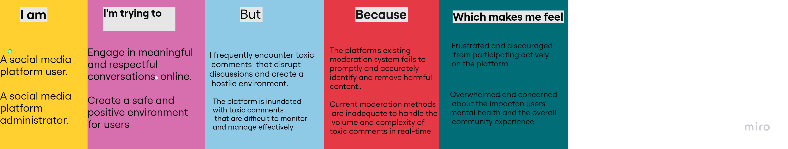

|  |  |  |  |  |  |
| --- | --- | --- | --- | --- | --- |
| **Problem**  **Statement (PS)** | **I am**  **(Customer)** | **I’m trying to** | **But** | **Because** | **Which makes me feel** |
| PS-1 | A car owner who recently got into an accident. | File an insurance claim for the damage to my car. | The process of getting an appraisal and estimate is time-consuming and inconvenient. | I have to take my car to a body shop, wait for an assessment, and then wait for the insurance company to process my claim. | Frustrated and anxious about the whole process. |
| PS-2 | A car owner who recently got into an accident. | Get my car repaired quickly and efficiently. | The insurance company's traditional inspection process is slow and inconvenient. | The insurance company's manual inspection process is prone to errors and inconsistencies. | Overwhelmed and concerned about the impact on my daily life. |